**Job Satisfaction Dashboard**

Final Project Write-Up

**Sasha Lawson**, Project Manager

ADVISOR: **Greg Chism**

Date: **December 10th, 2024**

Contents

1. Expectations 3

**Executive Summary** 3

**Expected Features** 3

2. Project Components 4

**Introduction** 4

**Data** 5

**Methodology** 5

**Outcome** 5

3. Feedback & Discussion 5

**Projects Obstacles** 5

**User Feedback** 5

**Future Case** 5

# Expectations

**Executive Summary**

This capstone project aims to provide college students with actionable insights into job satisfaction across a wide range of companies and industries through an interactive dashboard. This project will focus on highlighting key job and employee satisfaction factors that are not often aggregated together such as work-life balance, relationships with direct leaders, and other critical job satisfaction elements. The dashboard will allow users to filter these factors based on specific roles and companies allowing for insight into a particular career.

The data for this project will be simulated based on various pay-to-access sources such Qualtrics, Gallup, Mercer, etc. This allows for a view of diverse dataset on job satisfaction across various fictional companies in real industries. The data will be incorporated into an interactive dashboard designed for user-friendly navigation and insight. Users will have the ability to filter by company and specific job roles. These reports will include job satisfaction factors for the selected position, and clear data visualizations that will enhance the user’s understanding of the selected position and company.

**Expected Features**

* *Feature 1 (Task 1): Data Research and Simulation*

The ultimate goal for the dashboard is to connect to publicly available databases via API connections to ensure real-time data updates. However, in the “alpha” phase, data will be collected and simulated manually. Before this can begin, research must first confirm the existence of relevant data. After the research phase is complete, the data will be collected and/or simulated using programming methods.

* *Feature 2: Data Manipulation for Visualization*

The raw data from, even from simulated data, can often be inconsistent and incomplete. This warrants proper data manipulation before it can be used effectively. This feature will ensure that all data is standardized and structured.

* *Feature 3: Filterability Across Roles & Companies*

This feature allows users to filter the dataset in the dashboard by specific companies and careers. This filterability allows users to narrow down their search to roles that match their preferences. The initial plan for the filters will be industry, company size, location, and the specific job title.

* *Feature 4: Ability to View Overall Job Satisfaction Score*

This dashboard will provide an overall employee and job satisfaction score for each company and role based on an aggregate of factors. This score enables users to a “quick glance” view at the general workplace sentiment. This “quick glance” can be useful for initial comparisons between companies and roles.

* *Feature 5: Top Rated Employers for a Given Role*

Users will have the ability to see top rated employers based on their filtered career. Top employers will be ranked based on overall satisfaction scores. This aids users in quickly identify potential employers that best align with what they’re specifically looking for in a given role. This feature will be a valuable shortcut for users filtering through companies.

* *Feature 6: Top & Bottom Rated Job Satisfaction Factors for a Given Role or Company*

This feature allows users to drill down into specific factors contributing to both high and low satisfaction for a filtered role or company. By identifying which aspects of job satisfaction are most highly and lowly rated, users can gain a more in-depth insight into both the strengths and weaknesses of each company and role. For example, a user may discover that a company may excel in work-life balance, it also scores poorly in career growth opportunities. This balanced view of both strengths and weaknesses will give users a more complete picture of what to expect when considering a job offer.

* *Feature 7: View Industry Benchmarks*

The dashboard will enable users to compare satisfaction scores for filtered companies and roles against broader industry benchmarks. These benchmarks will provide users with a reference showing how companies and roles compare against the average satisfaction levels within its industry.

# Project Components

**Introduction**

The final results of this project will be presented through a dynamic dashboard created in Tableau. All code, data, dashboard events, along with a PDF write-up will be available on a public Git repository found here: <https://github.com/slawson-048/capstone-lawson>

**Data**

The “Data Simulation” found in the Git repository produces the following Excel files which are used within the Tableau dashboard:

* *Simulated_Data*

Contains job satisfaction data across various roles, companies, and industries. It includes key job satisfaction categories such as work-life balance, career growth, compensation, leadership, and colleagues. The dataset is designed for analyzing factors influencing job satisfaction.

* *Simulated_Data_Pivot*

Contains a pivoted version of “Simuated_Data” which is pivoted on the job satisfaction categories.

* *Benchmark_Data*

Contains benchmark data which is built off the “Simulated_Data”, with scores adjusted by either +50 or -50 to create variance between the original scores and the benchmark scores.

* *Benchmark_Data_Pivot*

Contains a pivoted version of “Benchmark _Data” which is pivoted on the benchmark job satisfaction categories.

* *Role_Data*

Contains role description data linked to the “Simulated_Data” to provide additional details about the roles.

*Data model used in the Tableau dashboard:*

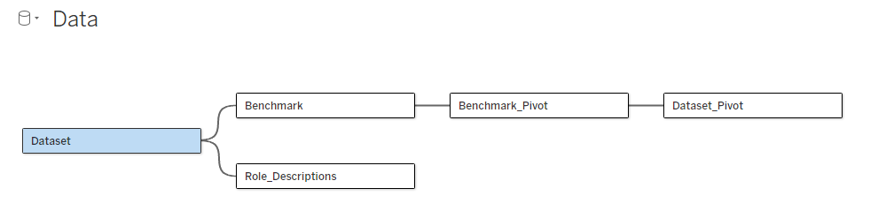

**Methodology**

(Talk through building code & dashboard—preview obstacles)

**Outcome**

(show off pictures of dashboard)

# Feedback & Discussion

**Project Obstacles**

The final results of this project will be presented through a dynamic dashboard created in Tableau. This interactive dashboard will allow users to filter data based on various employee satisfaction features, explore trends across various companies and data science roles. The dashboard will be designed for user engagement offering intuitive ways to visualize and gain insight. Additionally, the dashboard will include a report-styled portion that will function as an information dump to the current filtered company or role.

**User Feedback**

The final results of this project will be presented through a dynamic dashboard created in Tableau. This interactive dashboard will allow users to filter data based on various employee satisfaction features, explore trends across various companies and data science roles. The dashboard will be designed for user engagement offering intuitive ways to visualize and gain insight. Additionally, the dashboard will include a report-styled portion that will function as an information dump to the current filtered company or role.

Finally, all code, data, and forms of presentation will be available on a public Git repository found here: https://github.com/slawson-048/grad_capstone_job_satisfaction

**Future Case**

The ultimate